Setup & Firmware Uploading Guide
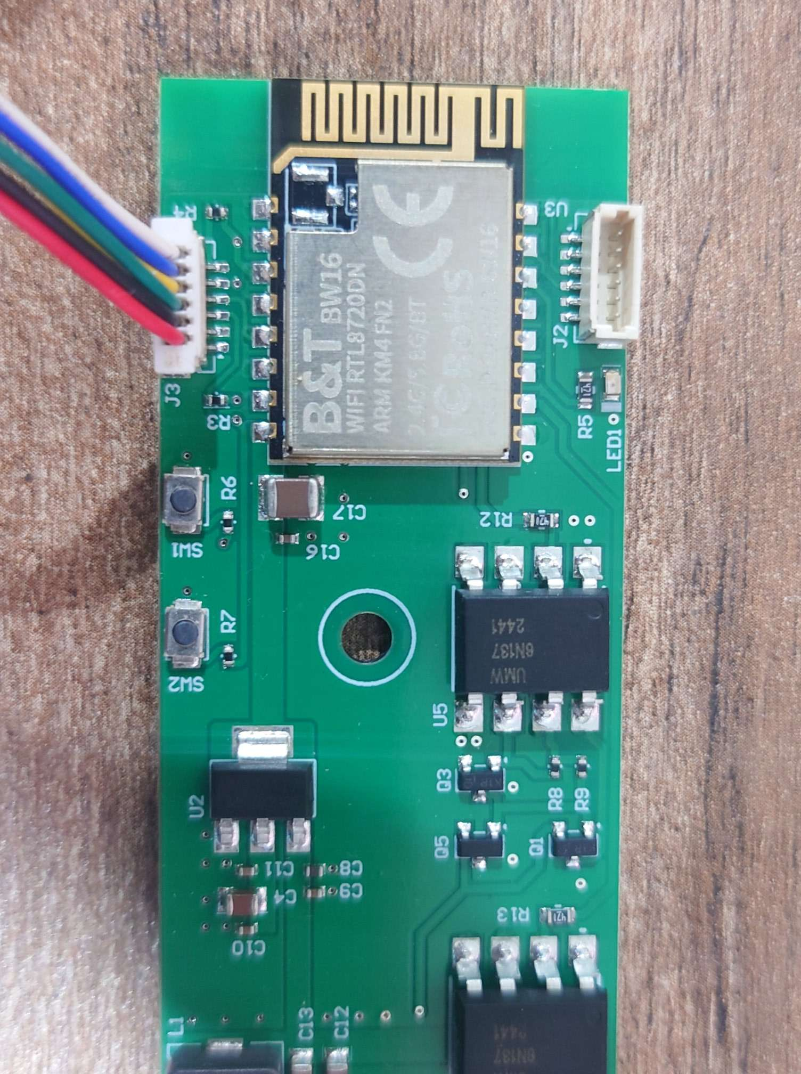
Figure: 1

As shown in the Fig: 1, there are two connectors available for Voltlink interface, “J2” & “J3”.
“J2” can be used as a standard serial interface. “J3” is intended for Firmware Flashing.
There are 2 buttons besides “J3” connector. SW1 is the “RST” button and SW2 is the “Burn” button as shown on above figure. Refer the following table for the functions of the buttons:
Button Functions | Button Process
Reset board | Press then release “RST”
Enter upload mode | Press and hold “Burn”  Press then release “RST”  Release “Burn”
Table: 1

There are two modes available for Firmware upload. “Auto Mode” & “Manual Upload Mode”. Table: 1, refers to the use of buttons in “Manual Mode”, Do note that the board is capable of “Auto Mode” and “Manual Mode” should only be used if errors are encountered during “Auto Mode” upload.
Hardware Setup:
Connect voltlink with Main-Board PCB, as illustrated in Figure: 2, Use the connection cable provided with the Voltlink adapter to connect “J1” from voltlink PCB with “J3” on Main-Board PCB.
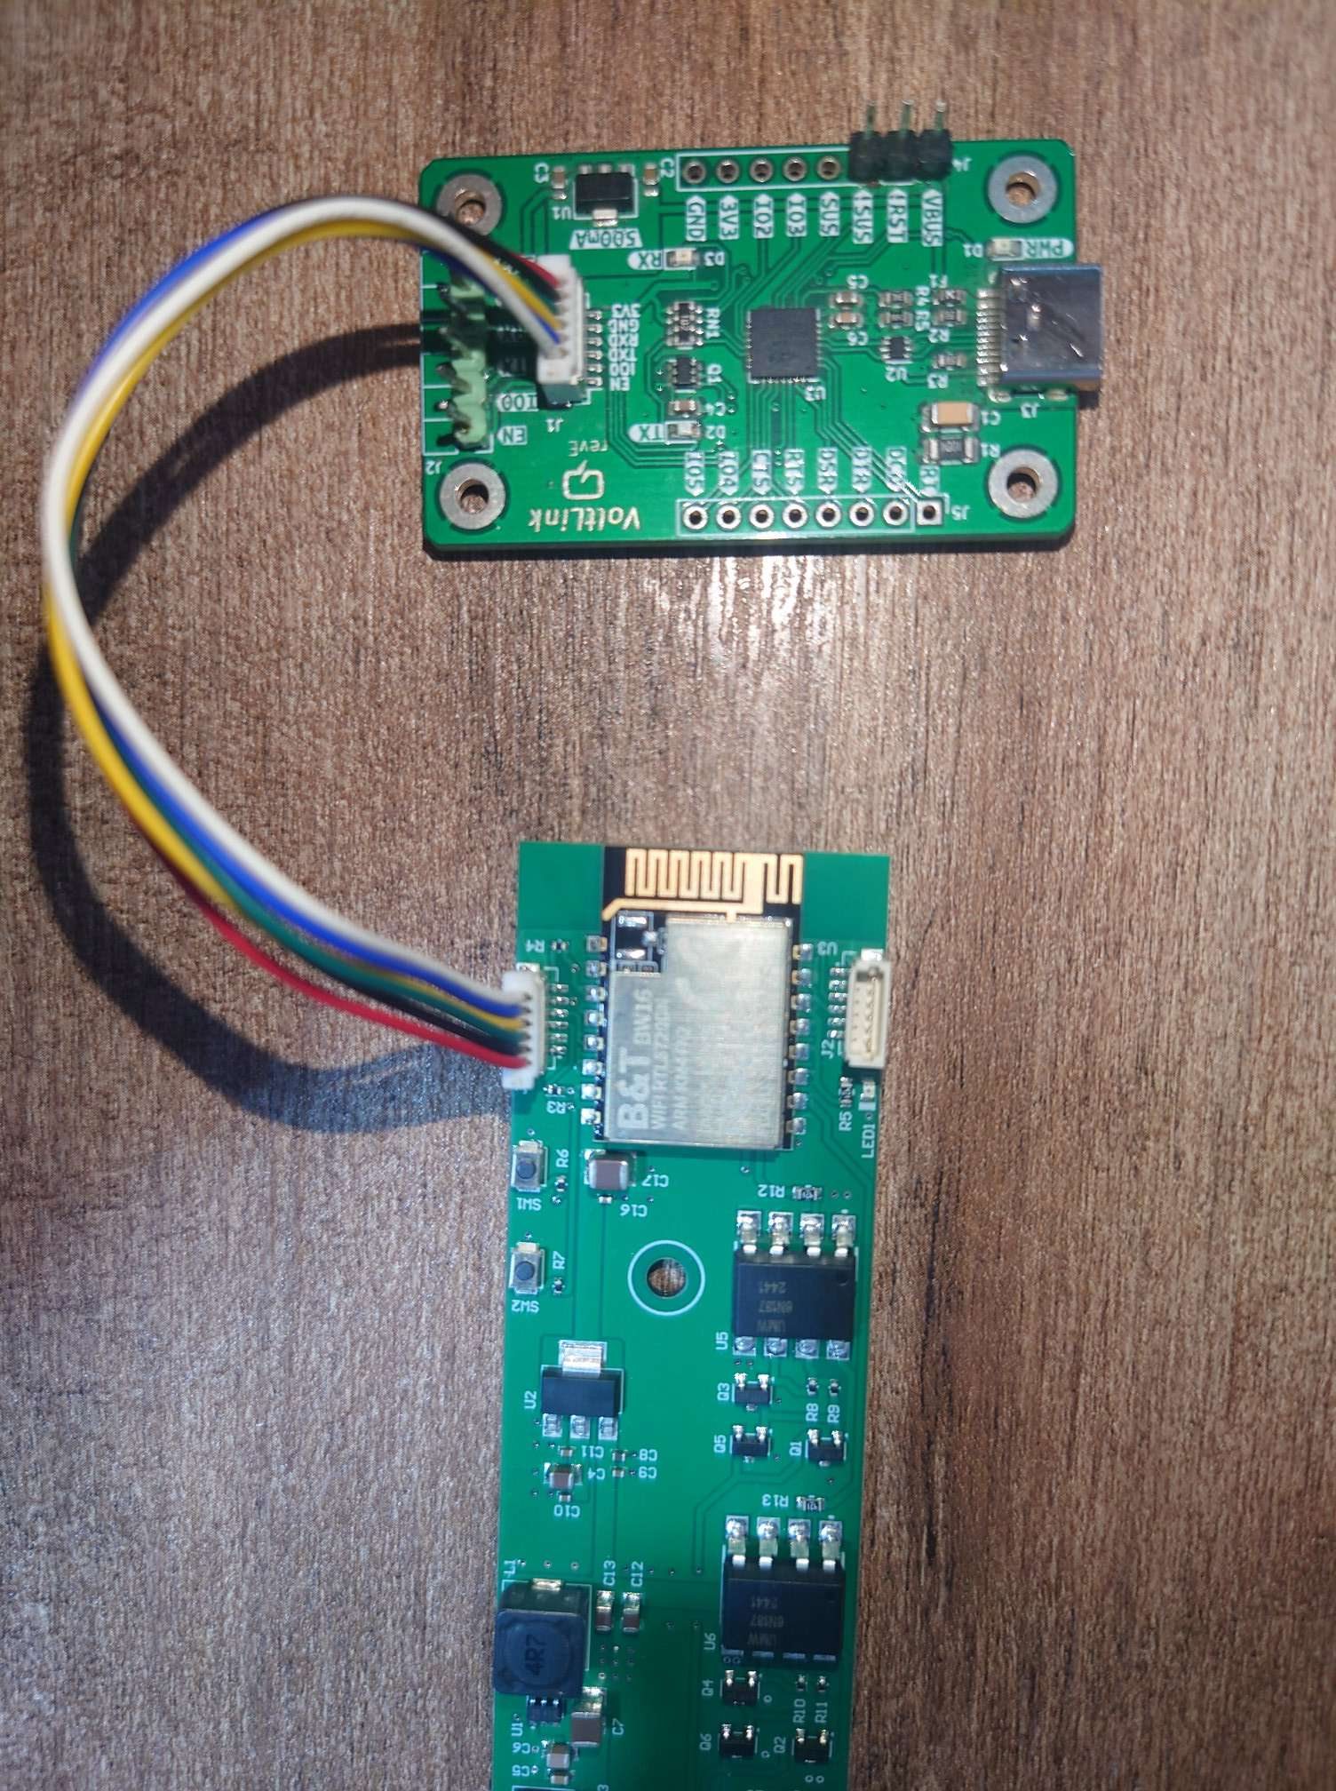
Figure: 2
Make sure both Boards are placed on an insulated surface before powering the boards.
Connect DC Barrel connector for DC 24V with Main-Board first, and Connect Type-C cable with voltlink Board and PC.
Power ON the main Board and make sure the LED D1 placed near Type-C connector on Voltlink Board is glowing. After powering on proceed to the next step.

Set up development environment:
Step 1. OS environment
BW16 (RTL8720DN) board currently supports Windows OS 32-bits or 64-bits, Linux OS (Ubuntu) and macOS. To have the best experiences, please use the latest version of OS.
For any Linux OS (Ubuntu) related issues, refer to https://forum.amebaiot.com/t/ubuntu-linux-environment/2259.
For any macOS related issues, refer to https://forum.amebaiot.com/t/macos-environment/2260.

Step 2. Set up Arduino IDE
From version 1.6.5, Arduino IDE supports third-party hardware. Arduino IDE is used to develop applications on BW16, and the Arduino basic examples (Peripherals & Examples — AmebaDocs 0.0.1 documentation)
Arduino IDE can be downloaded in the Arduino website: https://www.arduino.cc/en/Main/Software
When the installation is finished, open Arduino IDE. Go to “File” -> “Preferences”.
And paste the following URL into the “Additional Boards Manager URLs” field:
https://github.com/ambiot/ambd_arduino/raw/master/Arduino_package/package_realtek_amebad_index.json
Next, go to “Tools” -> “Board” -> “Boards Manager”:
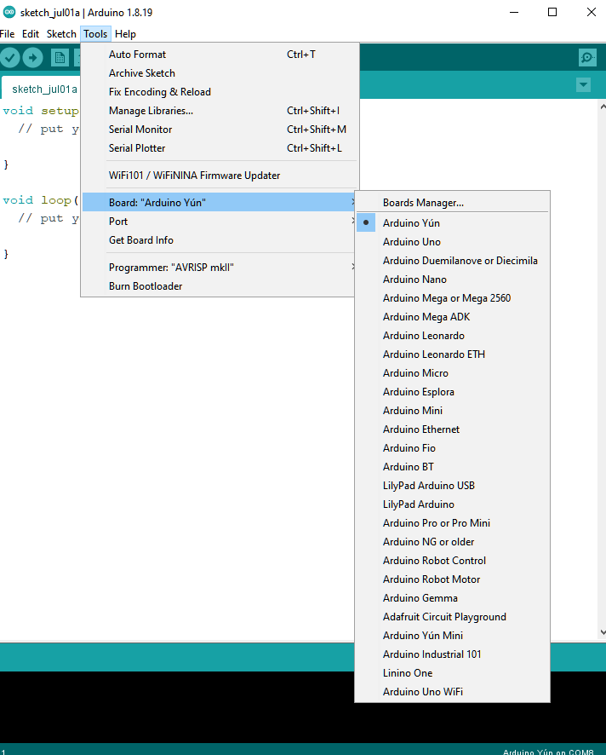
The “Boards Manager” requires several seconds to refresh all hardware files (if the network is in bad condition, it may take longer). Search “Realtek” then find “Realtek Ameba Boards (32-bits ARM Cortex-M33 @200MHz)” in the list, click “Install”, then the Arduino IDE starts to download required files for AmebaD family includes BW16 (The latest version should be 3.1.7 or above)
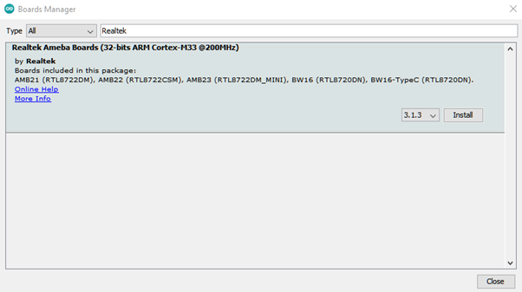

After the installation, select AmebaD as current connected board in “Tools” -> “Board” -> “Ameba ARM (32-bits) Boards” ->” BW16(RTL8720DN)”:
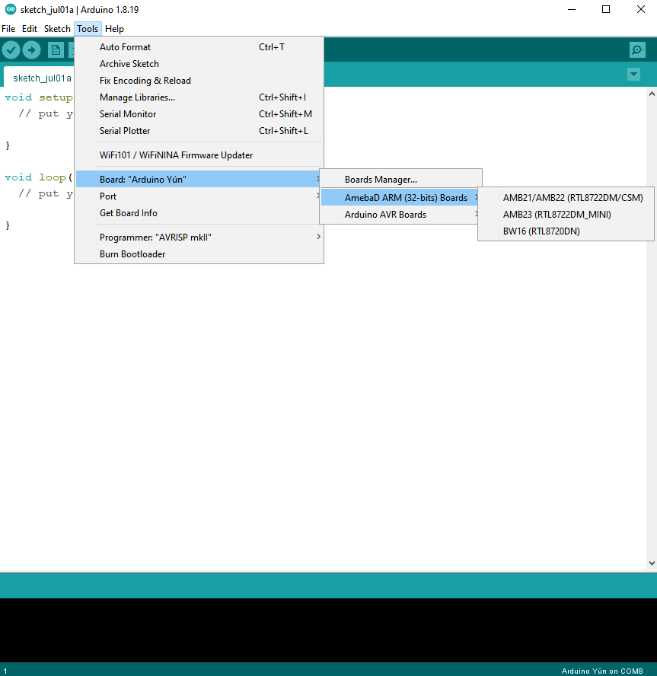
Step 3. Install the Serial port:
Make sure the voltlink-board is connected to computer via Type-C USB.
After connected, the USB driver will be automatically installed. If there is any driver issue of connecting board, please go to CP210x USB to UART Bridge VCP Drivers - Silicon Labs for USB driver. Check the COM Port number in Device Manager for Windows OS user:
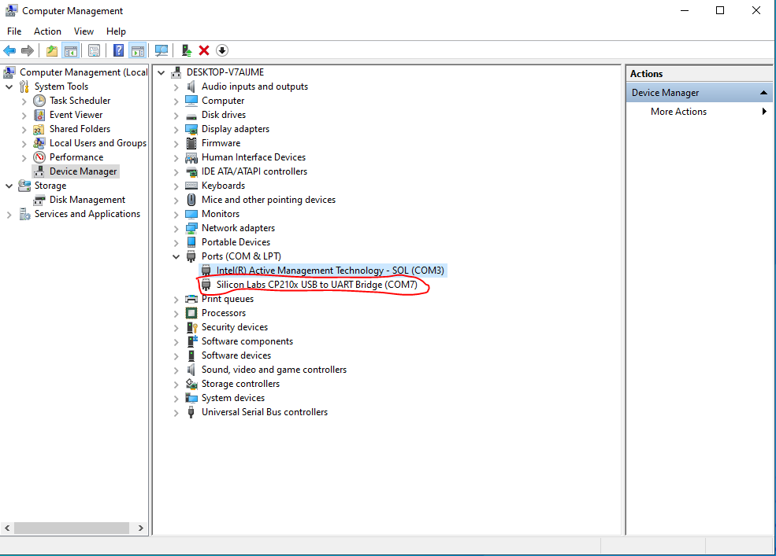
Go to “Tools” -> “Port” and select the correct COM port.
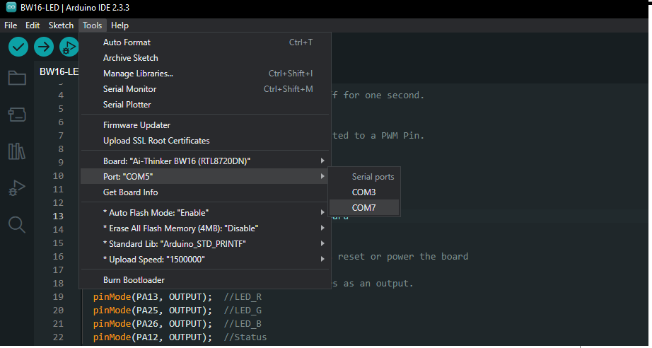

Go to “Tools” -> “Serial Monitor”, set the baud rate as “115200”, and press the RST button to check the serial port connection.
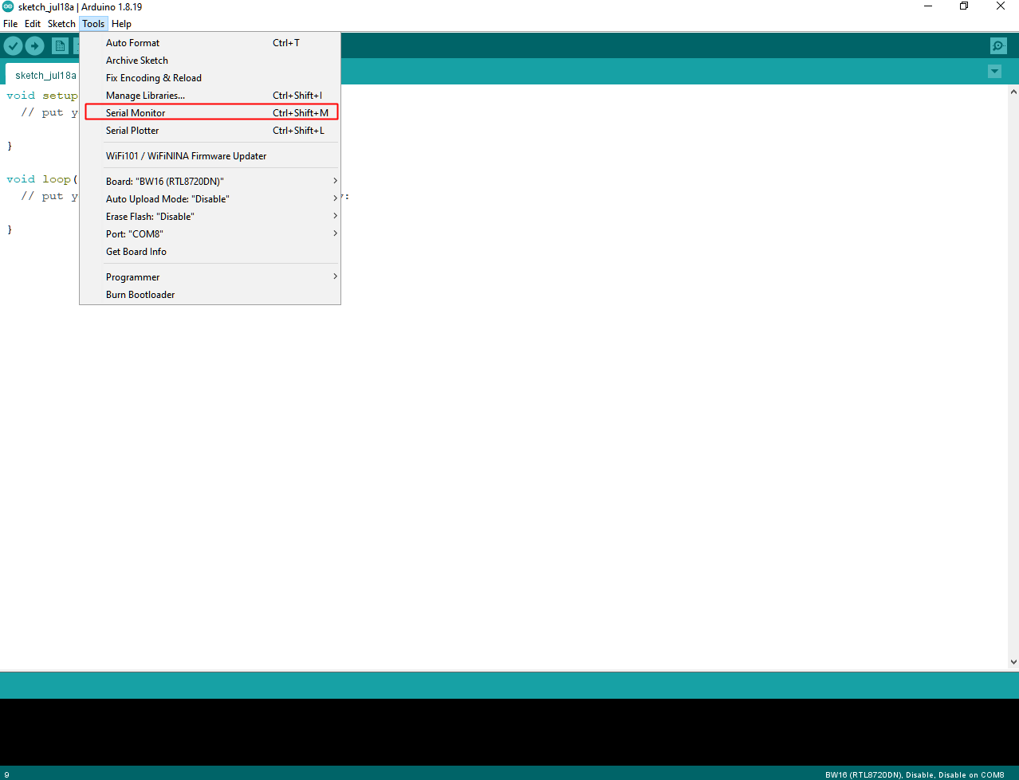

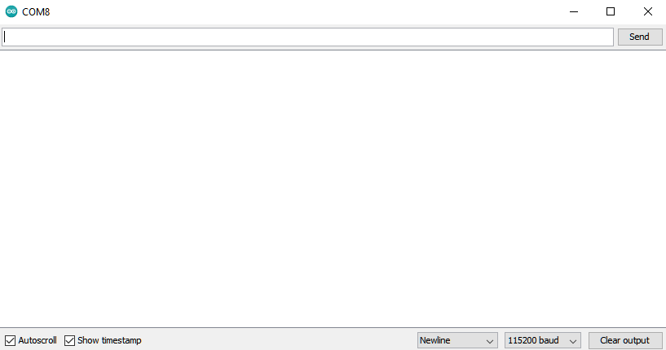

Step 4. Erase flash:
The factory default firmware needs to be erased first to make use of compiled firmware.
Method 1: “Erase Flash Enable” by Arduino SDK after V3.1.3.
Select “Tools” -> “Erase Flash” -> “Enable”

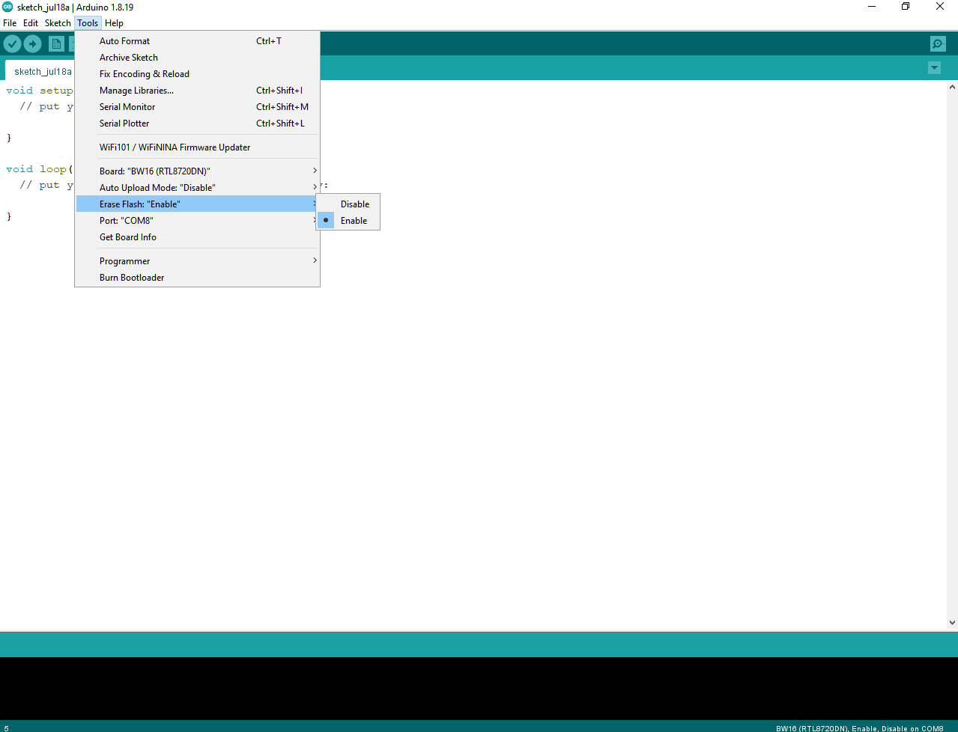

Then enter the upload mode.
Auto. Select “Tools” -> “Auto Upload Mode” -> “Enable”. Note that only boards with auto upload circuit build-in (BW16-TypeC) can use the Auto Upload Mode, otherwise it will back to normal upload mode and wait for 5 seconds.
Next, Select “Sketch” -> “Upload”. “Erase flash done.” will show up.
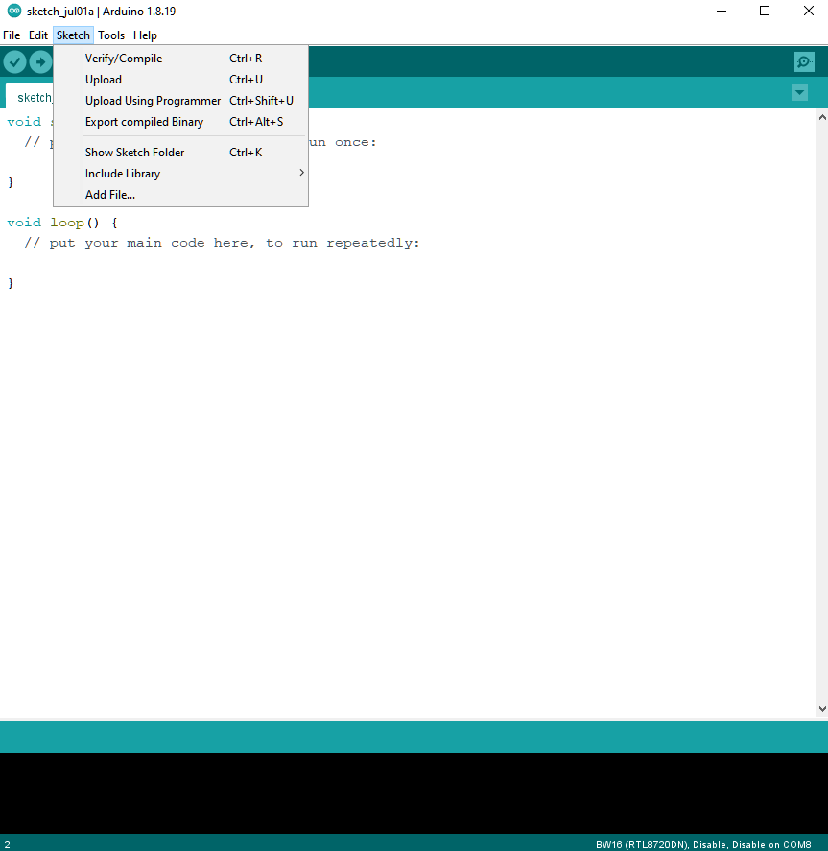
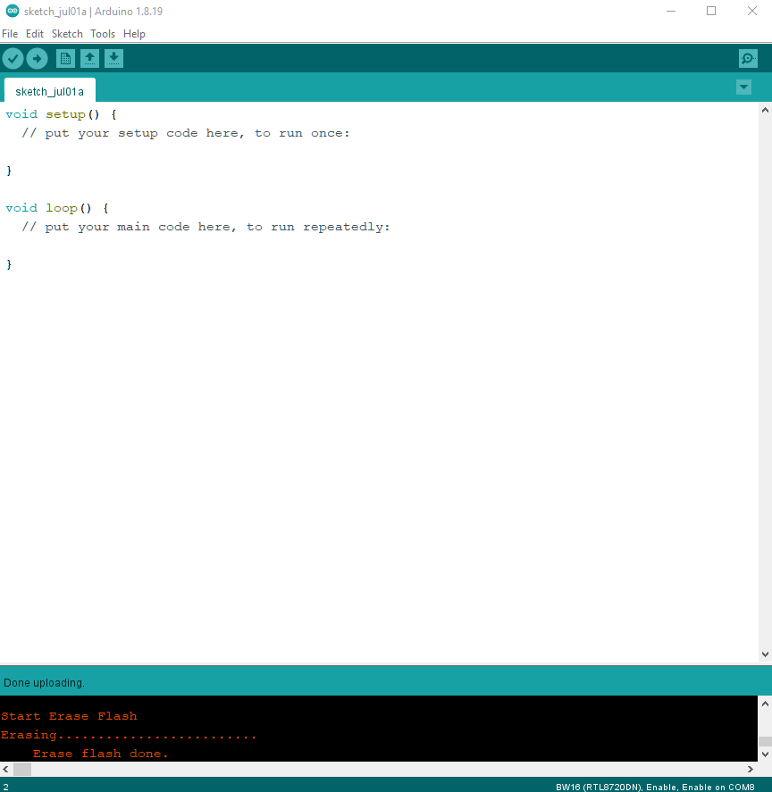
Check the serial monitor and reset board by press RST button. If only “#” shows that means erase flash success. Remember to select “Tools” -> “Erase Flash” -> “Disable”.

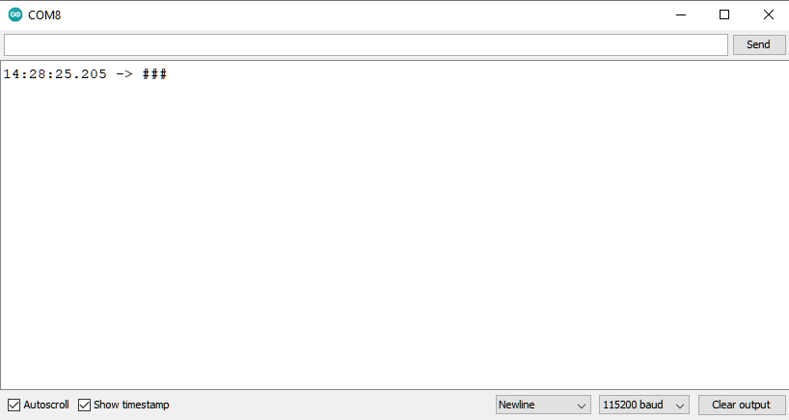

Try the First Example
Step 1. Compile & Upload:

Arduino IDE provides many built-in examples, which can be compiled, uploaded, and run directly on the boards. Here, we take the “Blink” example as the first try.
Open “File” -> “Examples” -> “AmebaGPIO” -> “BW16_RGB_LED”:
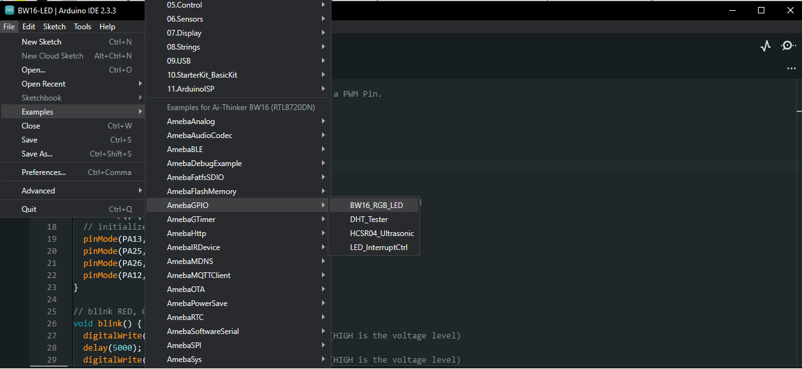
Make sure to change the Pin Definitions as follows:
On-Board Status_LED -----> PA12
LED_PWM0 -----> PA13
LED_PWM1 -----> PA25
LED_PWM2 -----> PA26

// the setup function runs once when you press reset or power the board
void setup() {
// initialize digital pin's from all 3 colors as an output.
pinMode(PA13, OUTPUT); //LED_R
pinMode(PA25, OUTPUT); //LED_G
pinMode(PA26, OUTPUT); //LED_B
pinMode(PA12, OUTPUT); //Status
}

Next, compile the sample code directly. “Sketch” -> “Verify/Compile”. Then if there is no compile error, followed by “Sketch” -> “Upload”.
• Check and select “Tools” -> “Erase Flash” -> “Disable”.
• Enter the Upload Mode. Auto. Select “Tools” -> “Auto Upload Mode” -> “Enable”/ ”Disable”.
• “Verify/Compile” and “Upload”. “Upload” includes “Verify/Compile”, “Verify/Compile” can be skipped.
Successful upload will show “All images are sent successfully!”

Step 2. Run the Blink example:
The board will be reset automatically, press RST button if board does not restarts. And the connected LEDs will blinking.

